**Contemporary Furnace Coiler Mills for Plates and Strips Rolling**

***V. Markovich. Expert. Published in Metal Supply and Sales, ¹1, 2008, page100.***

*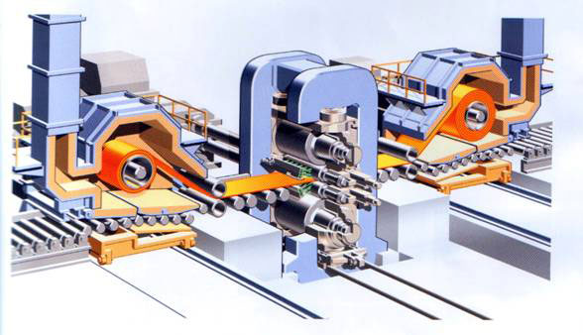****This is a 3D picture of the furnace coiler rolling mill***

Since mill 5000 has been widely discussed all over Russia, I have decided to express my humble opinion as well to help the Russian steel industry to pay attention to the problems that have existed in the world steel industry for a long time. I hope it will help the Russian steel industry to make the right choice. I will do my best…

I would like to present my idea of the plates and strips hot rolling mill. For the first time the idea of the contemporary mill was realized in the beginning of the 90s of the XX century at Oregon Steel Mills, Portland, Oregon, USA. CoilPlate process was engineered by Tippins using some patented control systems. Such a mill has proved to be one of the best in the world.

In spite of all the improvements, traditional reversing mills for plates rolling are still characterized by a high percentage of spoilage, low productivity, high inputs when changed for a new product type, as well as a considerable limitation in the range of rolled products. All the improvements of the sheet by sheet rolling process have resulted in a slight increase in technical and economical indices.

Today the process based on compact cast-rolling units is improved. The advantage of such a technological system lies in a multipurpose use of the equipment for one line can be used to produce plates of certain sizes as well as strip coils. Such a technological flexibility fully meets market requirements under conditions of a large-scale production of high quality plates and coils. Such a furnace coiler mill was named Steckel mill in the 30s of the XX century by the name of its engineer Mr. Steckel.

Production facilities involving Steckel mills based on contemporary technological process and equipment were built at steel enterprises in USA, Europe, China and other countries.

Due to achievements in the machine-building industry absolutely new technological solutions have been realized solving the main problem of the first generation furnace coiler mills – instability of sizes and characteristics as regards to the length of the finished coils. Now we can achieve high quality of finished strips matching the same achieved on broadband continuous and semi-continuous mills.

Relatively low capital and operation costs (30-40 % less) have enabled to produce strips and plates on the furnace coilers mill with a higher efficiency (in terms of quality-value). In 1990 - 2005 about 30 new or fully modernized furnace coiler mills were put into operation all over the world. The total output of such mills is estimated at more than 25 mln tons a year of high quality steels of different purposes. Experts believe such a trend will become stronger in the future. Advantages of such type of mills become more obvious. Coil Plate process engineered by Tippins has become a technological break-through in the production of plates and coils. The process has become a technological base for 148″ four-roller combined mill of 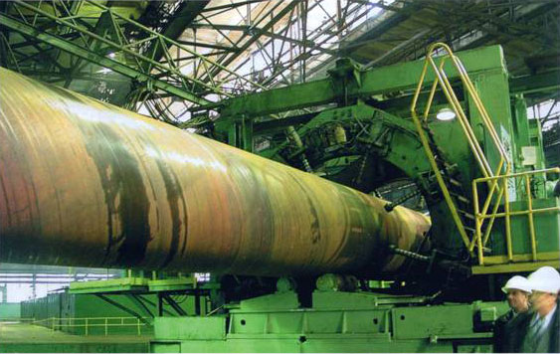the new generation built in the beginning of the 90s at Oregon Steel Mills in Portland, Oregon. In my opinion, so far this is the best mill of such type.

The process of direct rolling of broad slabs (up to 4600 mm) and thickness up to 300 mm (in some cases even more) right after casting has been engineered and improved. The process ensures a sufficient flexibility of dimensional and graded rolled products in combination with required qualitative and other characteristics of finished products. The technology enables to fully use the possibilities of the traditional rolling method and rolling with controlled temperature, thermal and mechanical treatment with accelerated cooling on the mill train.

Compact equipment setting considerably reduces investment costs. If the equipment is set up on one plant the time of technological route from melting to finished products sales is measured not by days, but by hours. Models with the productivity of 1.0 -1.8 mln tons a year can be started in any succession varying the range of products to meet the market requirements. Production costs are reduced considerably. Number of employees working in the whole complex does not exceed 300 people.

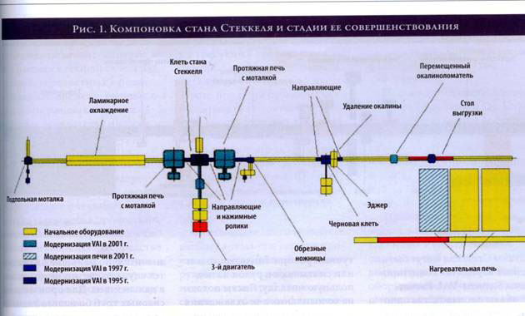

Possibilities of successive and multi-choice arrangement of the furnace coiler mill are hard to overestimate today. Picture 1 shows an example of an arrangement of the mill as well as stages of its modernization by years with the development of technologies and solving of new production problems (Brazil, 1995 – 2001). The concept and project are by SIEMENS-VAI. Such transformations on the traditional mill site are much more expensive in terms of time as well as capital costs.

Considerable advantages are achieved in energy carriers saving (hot charge, batched heating in furnace coilers, reduced number of passes, reduced strength of rolling etc.).

Today some projects of 5000 mills with furnace coilers are fulfilled. The possibilities of 5000 mill with two stands are much bigger in terms of output and wider in range of products, especially when it deals with production of very thick plates of special purpose high strength steels in controlled rolling and thermal and mechanical strengthening modes.

Various types of Steckel mills by SIEMENS-VAI are shown below.

One stand Steckel mill for plates and coils rolling. Engineered volume of production – 1.0-1.2 mln tons a year. Cast broad slabs are rolled in Steckel stands with a bigger length of rollers barrels on a plate rolling mill set up in the middle of the 90s of the XX century in China. The mill train is equipped with rotor cross cutting shears, a downcoiler for broad strips coiling, a plates and strips cooling unit, hot straightening unit and a cutting line (Picture 4).

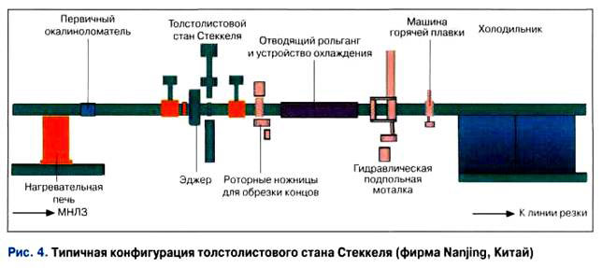

Twostandmill. Hot cast slabs with the weight reaching 65 tons (much heavier than slabs used on traditional plate rolling mills), are firstly charged into a furnace for heating up to 1100-11500C. Then the slabs are rolled in the stand used as a plate holder until its thickness is reduced to the thickness of the strip plate (usually to 100-25 mm depending on the final thickness of plates). The rolling continues on the Steckel stand itself with furnace coilers. The steel strip which length may reach a few hundred meters is coiled on furnace coilers where the temperature is evenly distributed on the whole mass of the coil. After rolling into a certain thickness and an accelerated cooling the strip is either coiled on a coiler or cut into separate plates with flying rotor shears. Then the plates are fed on a cooling bank for cooling and final finishing.

The application of the contemporary alloying method as well as thermal and mechanical treatments during controlled rolling and cooling enable to produce various product types without an additional thermal treatment outside of the mill train. It increases economical efficiency of the process of high quality plates production on Steckel mills.

As compared to plain plate rolling mill, Steckel plate rolling mill ensures a higher productivity at lower unit roll consumption. Costs of slab heating are reduced requiring no need to roll the plate in cross direction to reach certain width. Cutting of plates in certain length from a very long rolled semi product enables to considerably decrease spoilage percentage as compared to the technology of cross rolling of slabs into smaller lengths to reach certain width of the plate. Actual geometry of the length and width of the plate enables in most cases to avoid side flanges cutting using milling of a smaller surface if needed instead. It is hard to overestimate this when speaking about big diameter pipes production.

Steckel mills enable to produce strips of a bigger width as compared to plain broad band hot rolling mills. Steckel plate rolling mills due to their high productive flexibility enable to produce either plates or coils depending on the market requirements. This enables to meet a bigger demand at the same time reducing downtime caused by changeover of the mill. Picture 2 shows a classical type of two stand Steckel mill.

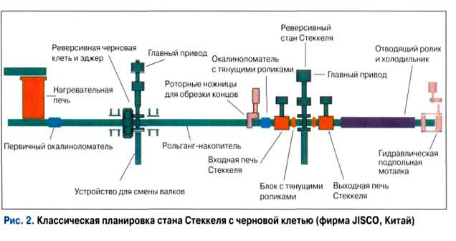

It is also possible to set up 2-3 additional finishing stands in between furnace coilers or after the second furnace coiler. In this case along with improving of the surface quality a further increase in productivity as well as production of a thinner strip can be achieved (the smallest thickness may reach 1.6 mm approx).

Rolling of Plates and Coils on Contemporary Steckel Mill for Production of Big Diameter Pipes for Main Pipelines

Today a principle feature of new technologies of production of flat tubular billets is that it they are based on metal science which presupposes a consequent ensuring of the best technological conditions controlled on-line from casting, steel pouring to final achievement of the required steel structure during rolling. Development of new technologies are constantly combined with modernization of equipment and technical means of process control including computer modeling and contemporary means of finished products control completely avoiding a possible negative influence of the human factor.

High quality is achieved by application of modern technologies out-of-furnace steel treatment ensuring certain content of sulfur (no more than – 0.001%), hydrogen (no more than 0.0002%), nitrogen (less than 0.005%) etc. A complete package of guarantees of required steel quality form new technologies of continuous pouring with set and controlled mode of metal crystallization. The technology of controlled rolling with an accelerated cooling, modern devices for technological processes control and main characteristics of finished products control based on statistics by a continuous monitoring keep a certain level on line. Stable steel characteristics of a big lot of finished products enable to forecast a high degree of reliability of future pipelines. It has taken Russian companies using pipelines and steel makers more than 30 years to understand it.

And, as a result I would like to show you a version of plates and coils rolling components on Steckel mill for production of oil and gas pipes.

What do we choose for setting up of production of flats in the nearest future (for example to produce big diameter pipes)? – Steckel Mill

Below please find a possible range of products of the mill for production of plates and coils for straight weld and spiral weld big diameter pipes.

Range of products and production volume

Coils

High strength steels (up to Õ100) for spiral weld (up to ø1620 mm and up) and straight weld (up to ø1020 mm) pipes made of cut plates used in oil and gas main pipelines.

Output of coils, ths tons per year      800.0   
Thickness of strips, mm    ……….     4.0-30.0  
Width, mm ……………………1050-3200  
Weight of coil, tons…………….up to 50.0

High quality structural steels of various purposes.

Plates

High strength steels (up to Õ100) for main oil and gas pipelines, high quality structural steels etc.

Output, ths tons per year……450.0  
Thickness of sheets, plates, mm …    4.0 – 50.0 – for tubes; plates – up to 150 mm  
Width of plates, mm ……………… 1050 –4600  
Output of plates, ths tons per year… 450.0

Design production capacity of plates and coils - 1 250 ths tons per year

The range of products defines production capacity for the chosen technology and equipment. Switching between plates and coils may change production capacity; the difference being about 500 ths tons per year.

Possibilities of the mill to supply steels to various tubes and pipes productions. What do we choose? Having wall thickness up to 30 mm and strength Õ80 – spiral weld pipe, for:

* Investments and production costs are lower by 35-40%;
* The pipe has operation advantages: it is less susceptible of longitudinal cracking (for it has welds angled about 300 to roll train);
* Structures of such pipes are more rigid which is important for field assembling.

A Few Words about Spiral Weld Pipes

Due to their high quality spiral weld pipes have been successfully used in building of oil and gas main pipelines for many years in Europe, Northern America, Japan, China, and Korea.

However, some are still prejudiced against their quality, which explains the popularity of straight weld pipes. The prejudice is based on the following:

* Either spiral weld pipes of a poor quality are considered which are produced at some tubes and pipes works with the application of one-stage molding and welding using billets (steel for tubes) of poor quality;

* Or customer’s lack of experience in application of spiral weld pipes,

* Or a large-scale PR campaign.

Today growing demand and consumption have speeded up improvements of tubes and pipes testing. As a result, all the spiral weld pipes by Salzgitter Group, for example in the world market are considered to be of the same quality with pipes with one longitudinal weld and are used in such critical fields of application as sea projects based on DNV, EN and other strict international requirements.

Thus, since 1987 Salzgitter GmbH has produced more than 4 000 km of big diameter spiral weld pipes for oil and gas pipelines. The customer list is very long including such world known companies as Ruhrgas, Wingas, Gaz de France, SNAM ReteGas, Enagas, Fluxys and Gasunie. These are just a few companies to mention. The works supplies big diameter pipes (from 508 to 1676 mm) of high strength steel coils (up to Õ80); wall thickness up to 22 mm. During the last 30 years more than 90% of pipes have been produced of steels of Õ65 and Õ70 strength classes.

A large-scale researches and tests have been done to forecast the degree of reliability of main pipelines of high strength steels. Basing on them, a number of recommendations has been worked out which are successfully applied today.

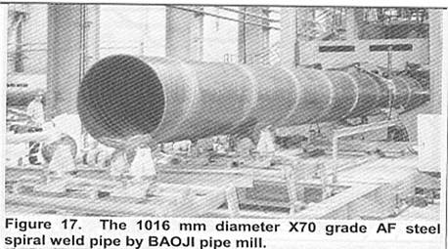It has become more obvious today that production of pipes using the two-stage technology in direct cooperation with supplies of high quality strip coils and more profound study of conditions of the route ensure a constant increase in the share of spiral weld pipes in the international market. Professionals have no doubt that in the nearest future big diameter spiral weld pipes for oil and gas transportation will occupy a certain niche in the market which is estimated at 80 - 85%. However, today quality of straight weld pipes in Russia leaves a lot to be desired since we have lost many technologies of production.

It is clear that it’s better for such major producers of pipes for oil and gas main pipelines as ÒÌÊ, ÎÌÊ, ChTPZ Group to have own productions of straight weld as well as spiral weld pipes. In my opinion we should also pay attention to the world trend of a constant increase in share of spiral weld pipes in this segment of the market.

Let’s take China for example. Building of a main 1691 km pipeline for transportation of 10 mln tons of oil by-products a year is about to finish on the South-West Chinese Plateau. The rout passes mountaneous regions and it causes certain difficulties. In building of the main pipeline spiral weld and longitudinal weld pipes of standard steel grades X52-X60 and diameters from 518 to 1219 mm are used. The share of spiral weld pipes in the project reaches more than 80%.

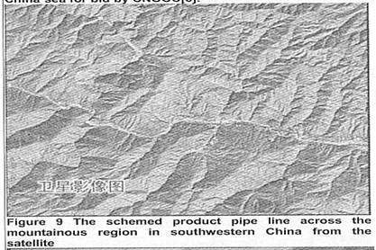Pictures 1 and 2 show separate sections of the difficult route including seismic resistance.

Straight weld pipe – a steel works with a full production cycle or just one electric furnace are estimated Today we give the first priority to a metallurgical complex with an electric furnace with the capacity of 1.5 – 2.0 mln tons a year. Either process has no advantages in melted steel quality. However, economical situation interfered. It has become clear today that when there are no advantages of geographical location, regional market, etc. a full cycle steel works with the annual capacity up to 3.0 mln tons cannot cover all the expenses related to environmental protection producing pig iron of ore and coke. The traditional plate rolling mill 5000 or the Steckel mill for production of plates of the same type as well as strip coils with thickness of up to 30 mm.

Today a two stand Steckel mill is more popular in Russia. The design of the mill may be exclusive meeting certain requirements of the market. It is very important especially at the initial stage for it determines the amount of investments and choosing of site.

Development of technologies and equipment of the Steckel mill today enable to solve all the tasks which can be solved on traditional plate rolling mills yet with a decisive advantage  – coil.

We should not forget the traditional 5000 mill used in Russia as well (at Izhora for example). In my opinion it is sufficient for production of high quality straight weld pipes in Russia for future pipelines. Of course it will require a complete reconstruction and big investments (intellectual, marketing, financial etc.), yet it is all real. We need to correct mistakes that we have made and ensure a possibility to reach the goal in the nearest future. In other words, we need to use common sense before it is too late. It will be possible to solve the task if we have highly professional employees at the steel works.

Where is the Russian Steel Industry Today?

It would be illogical to speak about production of high quality plates and strips as well as pipes for main pipelines apart from understanding (realizing) the situation in the Russian steel industry as a whole. Nobody wants to speak about it openly, but in 1980 – 2000s a quiet, yet significant in its consequences revolution took place in Russia which has gradually abolished such a notion as quality. We have done a good job with our bulldozers on this quite a sensitive field.

The Russian steel industry is torn apart. The depreciation of the main production facilities exceeds 60%. Their modernization did not exceed 0.5% in 1991-1998 and from 0.6% to 2. 5% in 1999-2006, whereas the smallest necessary level is 6-7%. A constant shortage in financing and an inefficient use of funds (quite big, by the way) can not help affecting the industry.

Let us consider industries related to the steel industry and affecting it. Depreciation in machine-building has reached 75%. However it reduces slowly in the physical sense for depreciation of the assets is about 10 times faster than modernization. The situation in the housing and communal complex is terrible. Depreciation of the railway has reached 60%. The allowed safely level reaches 30%. The same situation is in oil production and oil chemistry. Electric power engineering is depreciated 50%. Russian aircraft engineering is one of the oldest in the world. In 2-3 year half of aircraft will be disassembled. During the communist times people took care about reliability of rails, main pipelines, electric networks etc. in such a way that their actual operation time is much longer than that stated in documents. We still use reserves from the communist times. However, any inheritance will come to an end sooner or later. Experts say it will happen in 2008-2010s which is pretty soon.

People do not speak much about cataclysms (especially ecological) in the steel and mining industries as well as power engineering. However, they happen quite often causing severe losses.

Taking into account the speed and quality of our work we will not have enough time to modernize assets, especially infrastructure. Let’s take Transneft as an example. It invests more than $ 200 mln taking care of its pipelines. And sooner or later they will be in a perfect order. When? If nothing happens, by 2035! No comments. At the same time an actual accident rate of Transneft pipelines 4-5 times higher than declared. So, let’s hope nothing will happen.

The steel industry is in the same swamp. Carefree manipulations with technical and economical reports (first of all related to quality of products), as well as thick mist over financial activity of steel works speak of an amorphous state of the Russian steel industry. Yet unrestrained optimist of bureaucrats and top managers in their declarations together with IPO seem strange to say the least.

The actual situation is this: while the steel industry is quickly developed all over the world, we have not created anything deserving only buying real estate and juggling with shares. The lack of technological processes enabling to produce competitive metal and steel products really upsets. The steel melting industry has broken all the records of rudiments in spite of a recent increase in volumes of steel melting in electric furnaces. There are no modern complexes with equipment and technology monitoring, and process control. Without it we can not guarantee high quality of products at all stages – from raw materials to finished products. We do not have many opportunities to respond to modern technologies that today quickly come into out lives becoming in 2-3 years applicable in production

Today everybody knows the European experience, not to mention Japan and its daughter Korea which can be compared to a Brazilian football team. There is no much point in speaking about consequences of the today’s strategy of the development of the electric steel melting. Dead-end. Converter production still uses technologies of 40-30 yearsago.

There are just a few units of out-of-furnace steel treatment – a decisive element in the process of production of high quality steels for pipes. The main part of melted steel is treated on old type continuous casting machines with a limited possibility to control crystallization process, as well as other processes in the production of high quality production on-line.

It concerns rolling as well, where the situation in the sheet rolling really upsets. Flats are a decisive segment in steel consumption in developed countries. The biggest success has been achieved in this segment of the world steel industry in the last decades.

Our lagging behind is getting more and more serious in spite of good investments. Today much has been invested in it, yet inefficiently. There is a chaos in understanding of strategic goals. There is no such a notion as technological marketing. The technological chain as well as vertical responsibility are week at the steel works. Nobody is responsible for the final result, the final product.

Corruption in the producer – consumer chain, price for resources (labor, raw materials etc.) are political, rather than economic problems. Everybody understands it. Ambitious tasks have been set up, intentions have been determined, specialists have been trained yet, no result. Today we have more oligarchs than qualified engineers. I do not say the situation is hopeless, yet it is very serious.

Officials of the highest rank have already come to understanding that further neglecting technologies the contemporary civilization rests upon will be dangerous. We do understand that such diseases cannot he healed only by orders and decrees, we need to start doing something about it.

**Conclusion**

Flats producers as well those who plan to extend already existing production facilities show interest in Steckel strips and plates rolling mills in terms of investments. Different arrangement solutions enable to specialize in rolling of carbon, corrosion-resistant, or special steel grades, flats or long products in a broad range and big production volumes. Today it concerns production of plates and strips for oil and gas main pipelines. Numerous design improvements in combination with modern control systems guarantee high productivity, quality of finished products and economic efficiency of production requiring much less investments compared to traditional plate rolling mills.